**Software lab**

1. Design **a website for your college** using the below template. Create separate pages for each department using external link.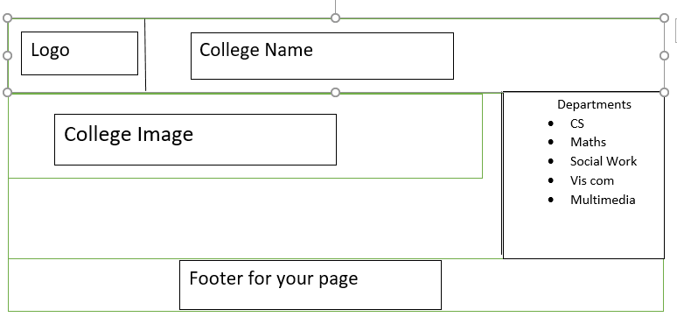
2. Create a time table using HTML and CSS.
3. Create a webpage for university exam registration using forms.
4. Write a JavaScript program to find the area of a (I) circle, (II) square and (III) Rectangle.
5. JavaScript program **to validate the employee registration form**
6. Create a simple calculator using JavaScript.
7. Create a JavaScript to validate a given email id.
8. Write a JavaScript program to find that the given number is prime or not.
9. Write a JavaScript program to find the number of vowels in a string.
10. Design a php page for getting marks of six subjects for a student and create a well formatted mark sheet.
11. Write a php program to check whether the given number is Armstrong or not.
12. Create a login page using php and session.
13. Develop a php application for recording students details(admno, name, DOB, address, father’s name, mob number).Perform insert operation.
14. Develop a php application for recording students details (admno, name, DOB, address, father's name, mob number). . Perform delete and update operations.
15. Design tables to store book details (book no, title, author, price, date of purchase) and insert five records. Create a search page in php for displaying book details based on its title.
16. Form validation using php.
17. Write a program in php to find the visitors count.